Low-Fi Report

**Our team:**

* Sarim Zafar (BSCS13026)
* Ammar Ahmed (BSCS13034)
* Shahzaib Javaid (BSCS13053)

**Introduction:**

PyschPk is a mobile and web based application for measuring and validating the mental capabilities of an individual. The problem we are trying to solve is in the context and culture of Pakistan, that what are the ways to identify the cognitive abilities of a person that match the requirements of a specific role?

**Initial Sketches:**

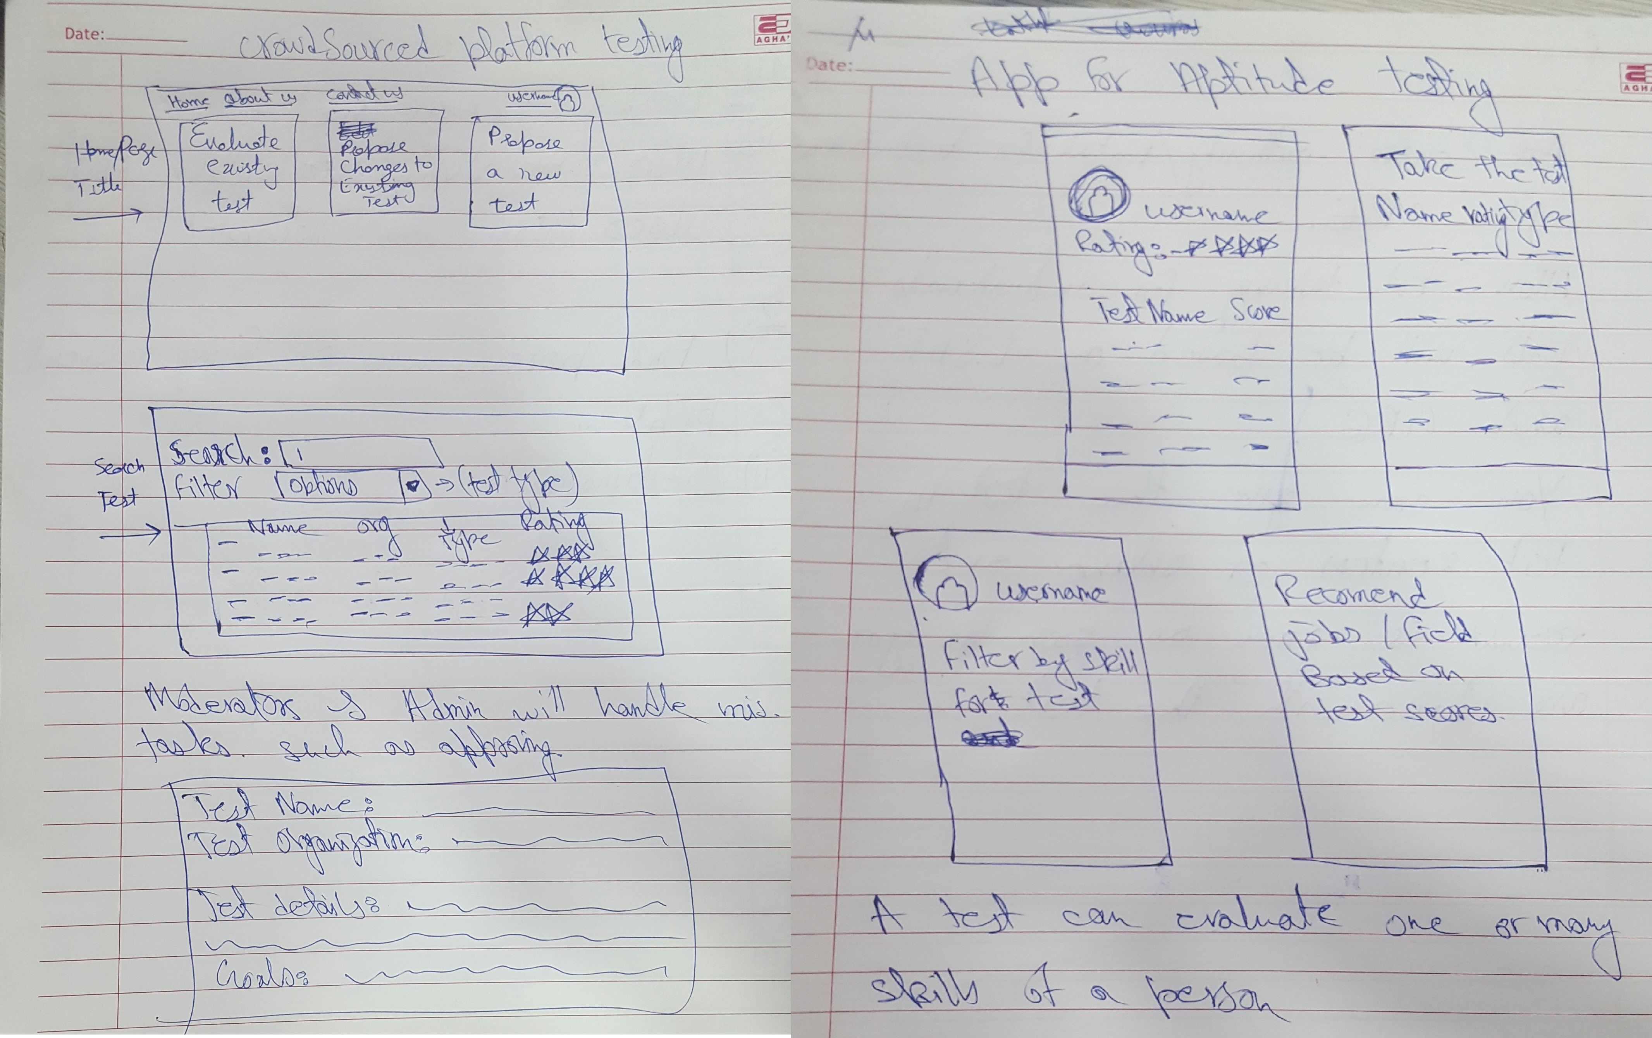

**Prototype 1:**

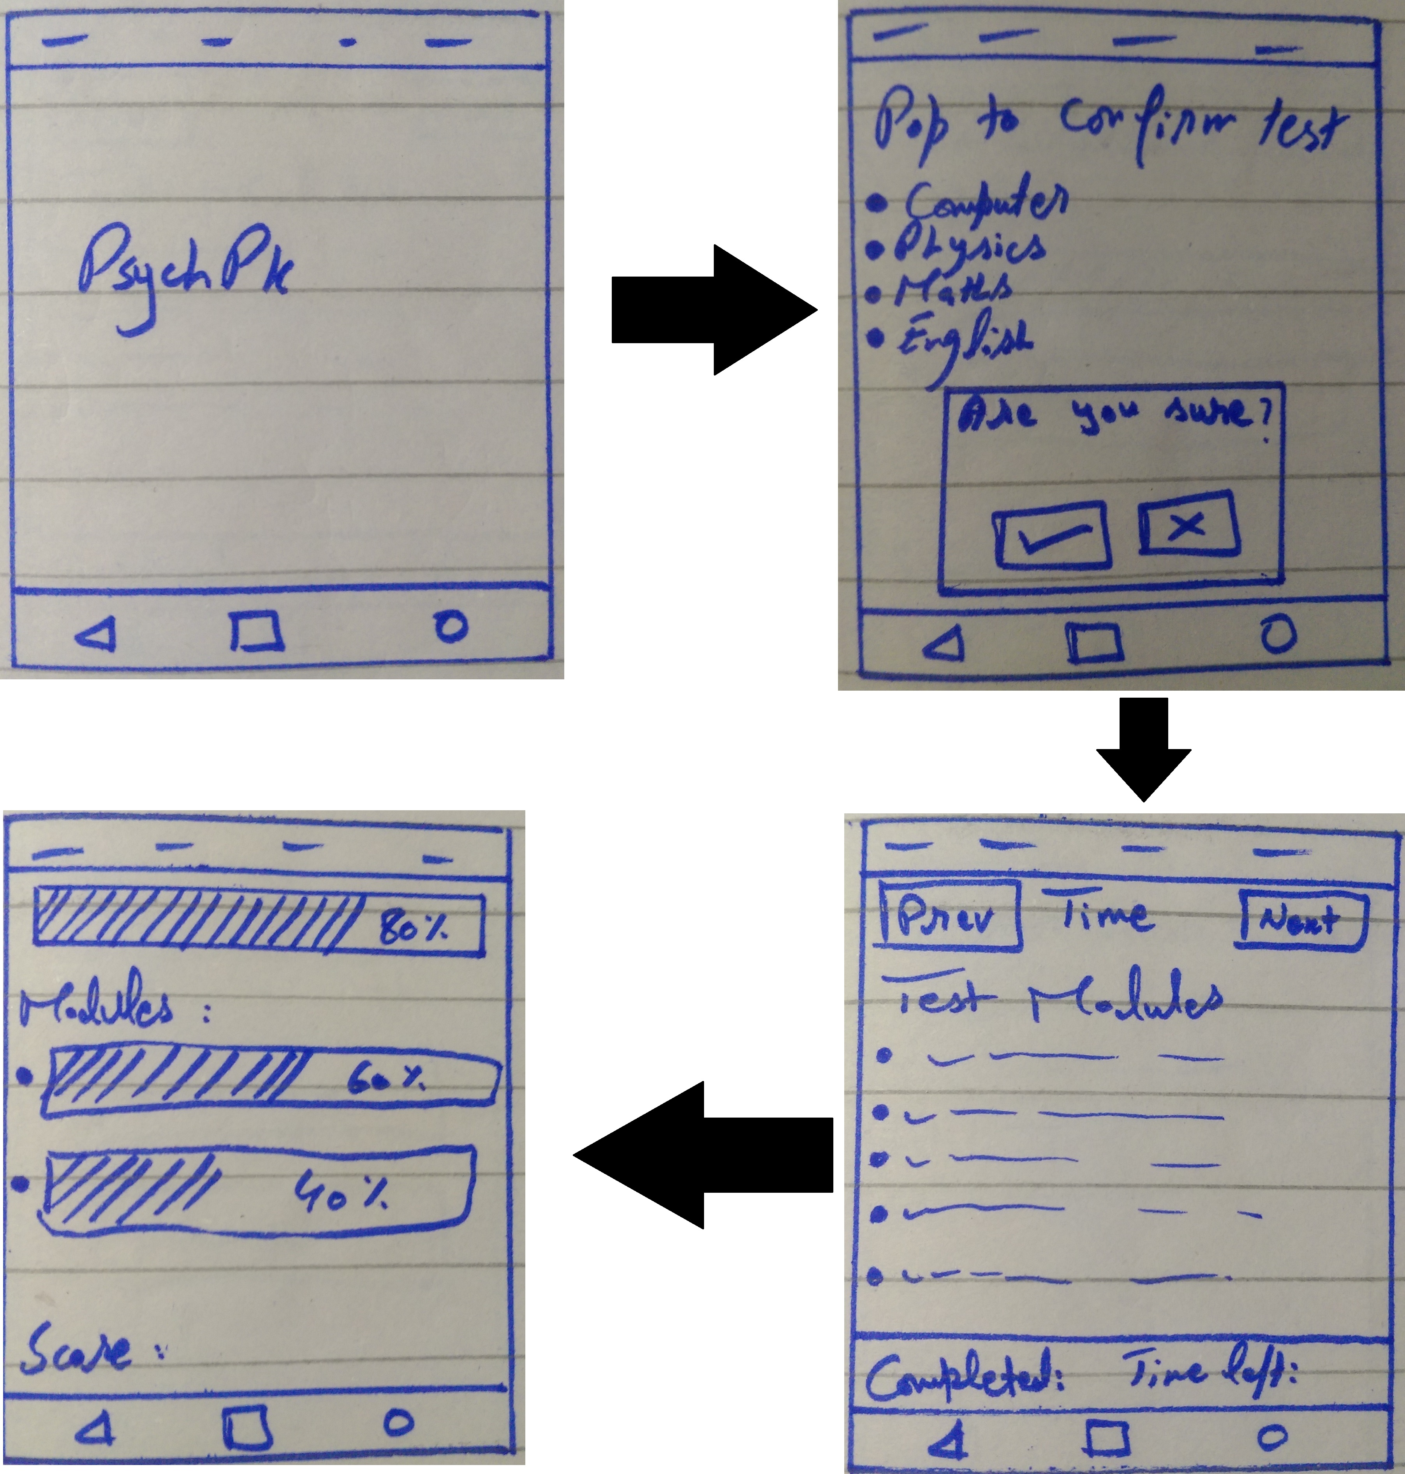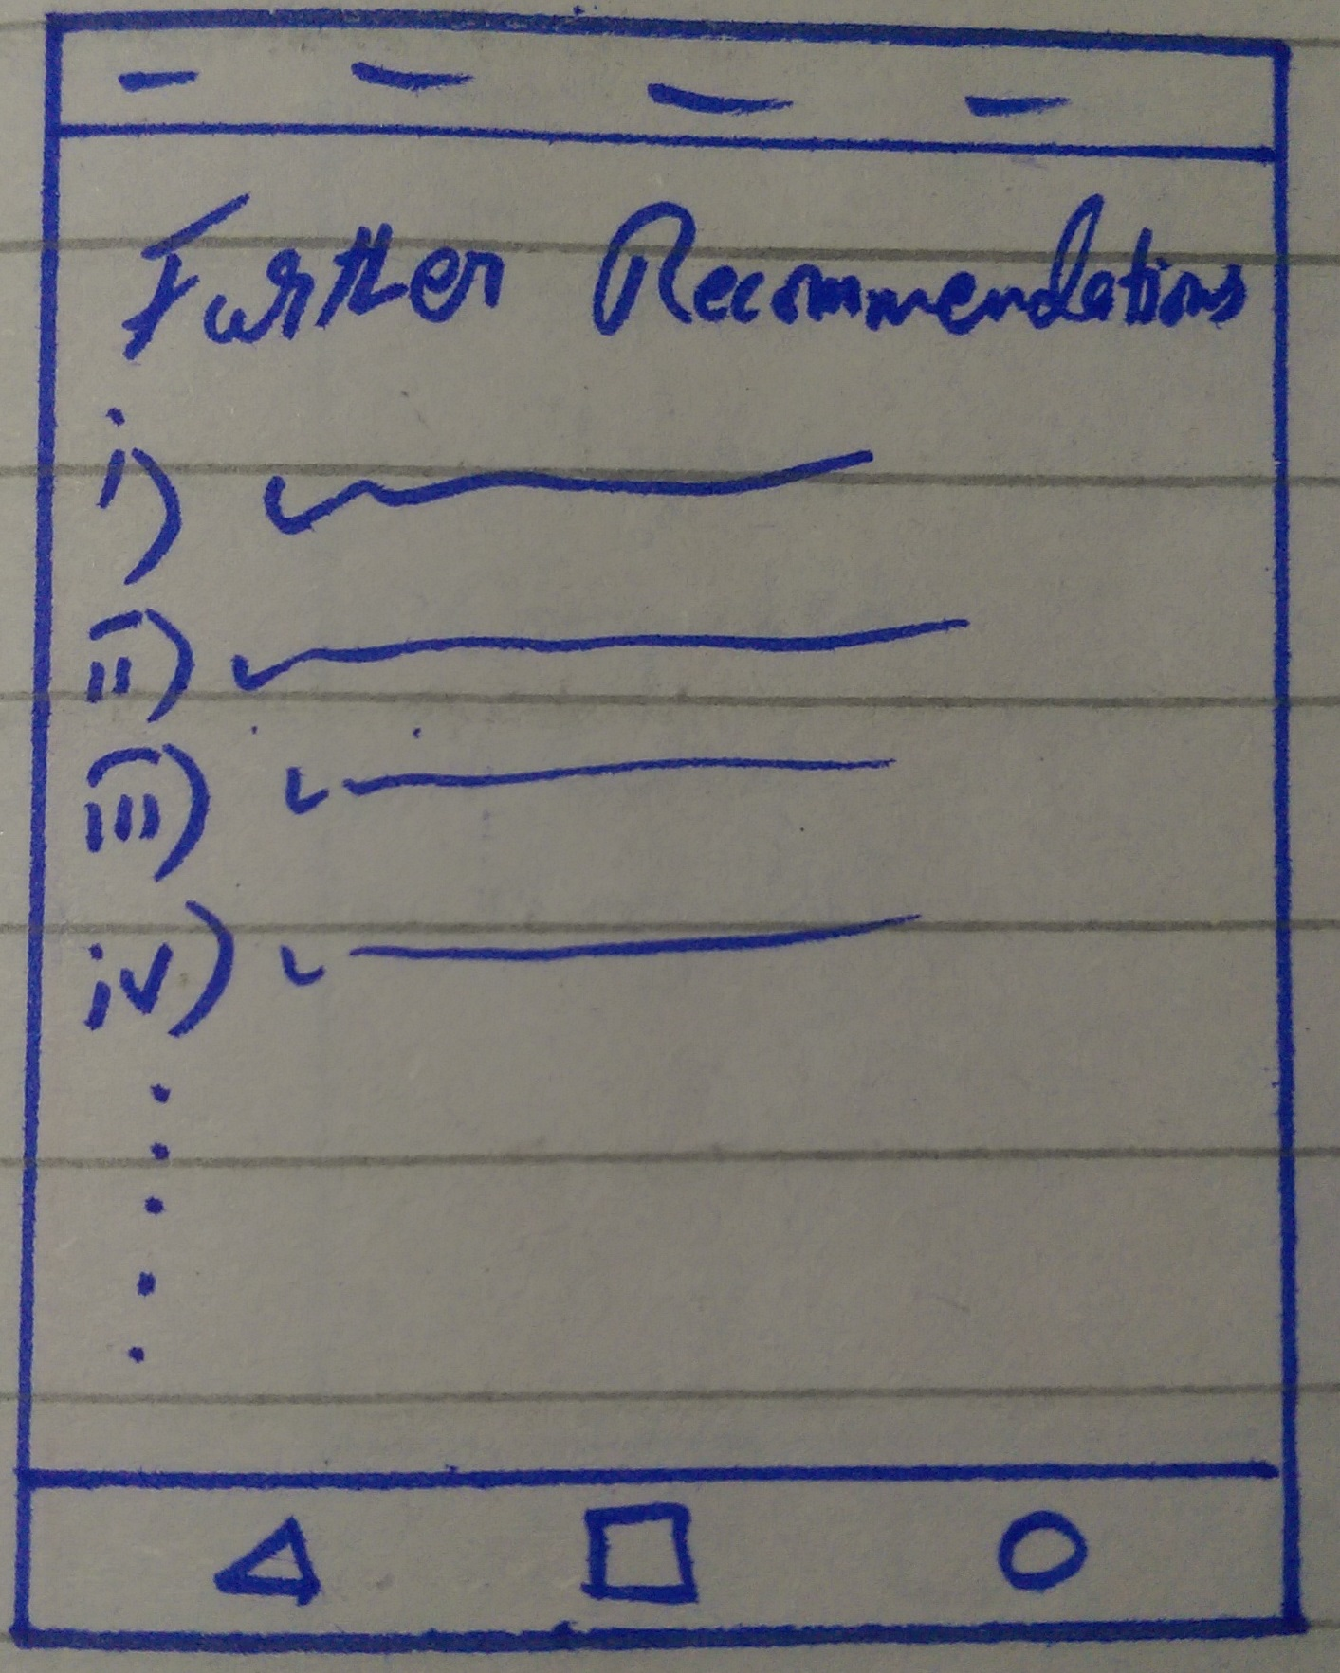

**Method:**

When you start the application, it will firstly show the title screen of app with logo “PyschPk”. Then a pop up screen will be shown, which includes the list of modules to be selected by an individual to give a test. An individual will select a module and then a confirmation message will be shown. User confirms with “Yes” and then it will take user to the test screen. The test screen will have the time and previous/next option at the top bar, and then the list of selected test modules in the middle of screen and completion status and left time at the bottom of screen.

User comes to the questions taking screen now and the test is being taken. This screen will show the total status of testing modules at the top bar of screen and separately modules’ status in the middle of screen. And then it will show the score of test at the bottom of screen.

After the tests have been taken, then this app will take user to the recommendations screen, where user can find further more recommendations and suggestions for him.

**Testing:**

**Prototype 2:**

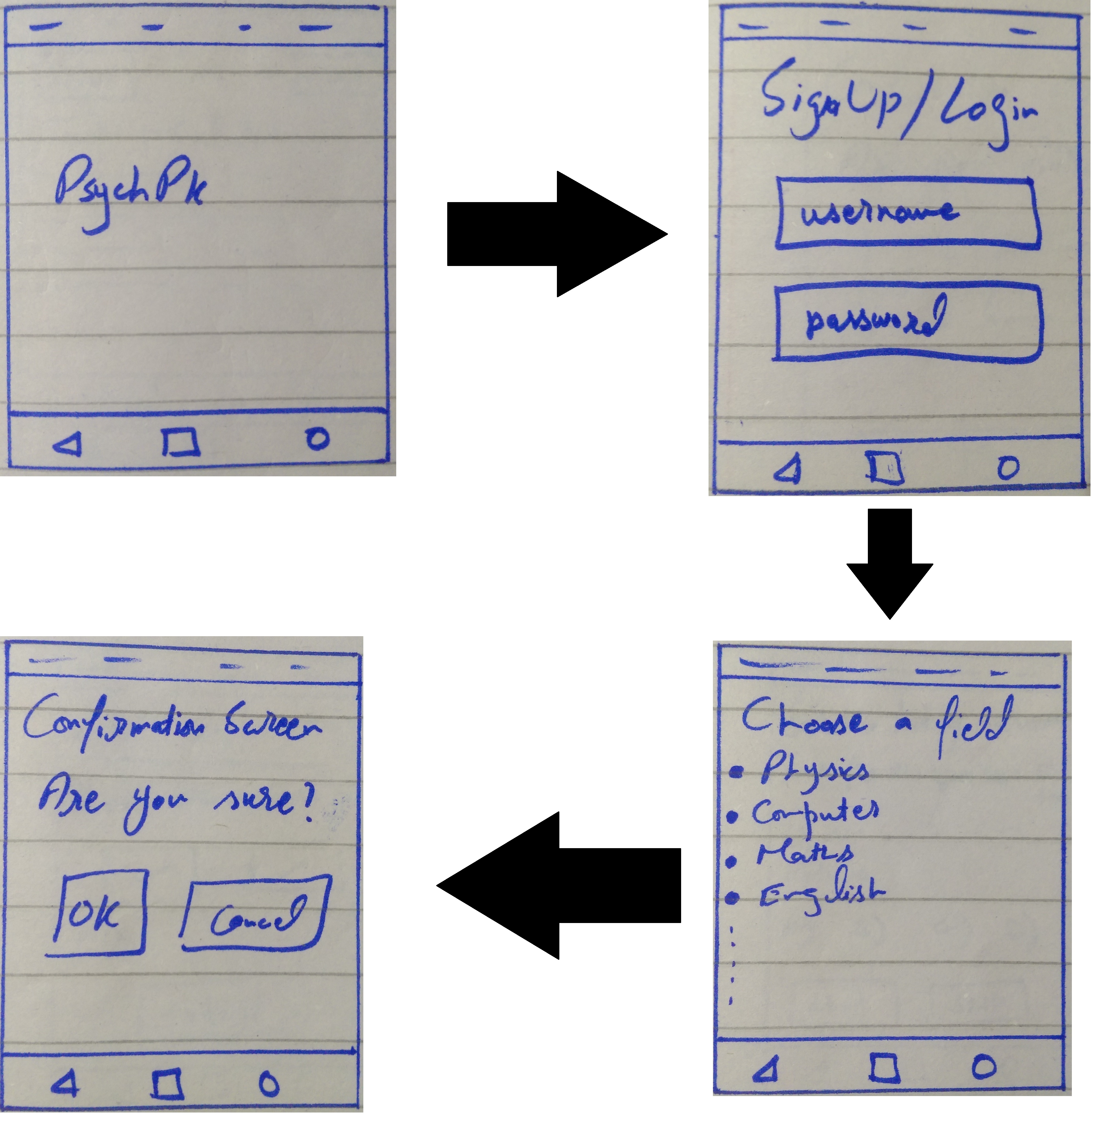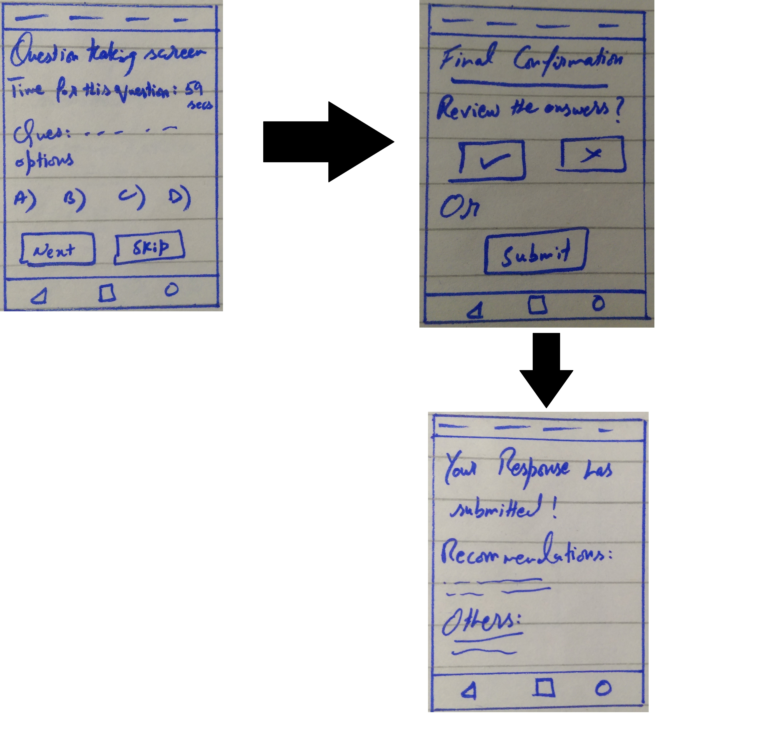

**Method:**

When you start the application, it will firstly show the title screen of app with logo “PyschPk”. Then a “SignUp/Login” screen will appear. User will sign up if he does not have any account earlier or login simply with his username/email-id and password. Then a pop up screen will appear, which includes the list of modules to be selected by a user to give a test. User will select a module and then a confirmation screen will be shown. User confirms with “Yes” and then it will take user to the test screen. The test taking screen will have the time for a question of relative test at the top bar and the question with its related options to select in the middle of screen. Then it will have the option for “next question” or “skipping the current question”. You will click the next button for further questions and complete the test.

After completing the test, the app will take you to the final confirmation screen for submitting the answers or reviewing for last time. If you want to review the answers, you will click on “yes”, otherwise you will click on “no” and submit the answers.

After submitting the answers, app will take you to the score and recommendations screen, where you will get the score of test and further recommendations.

**Testing:**

**Prototype 3:**

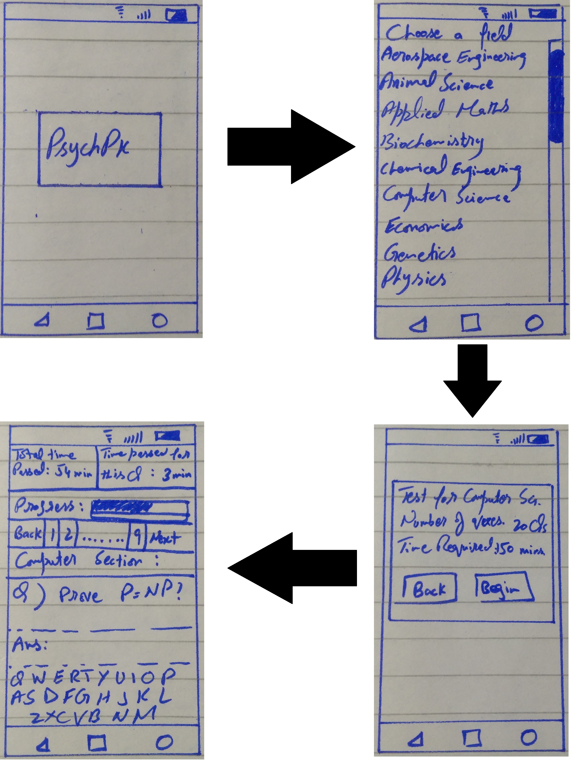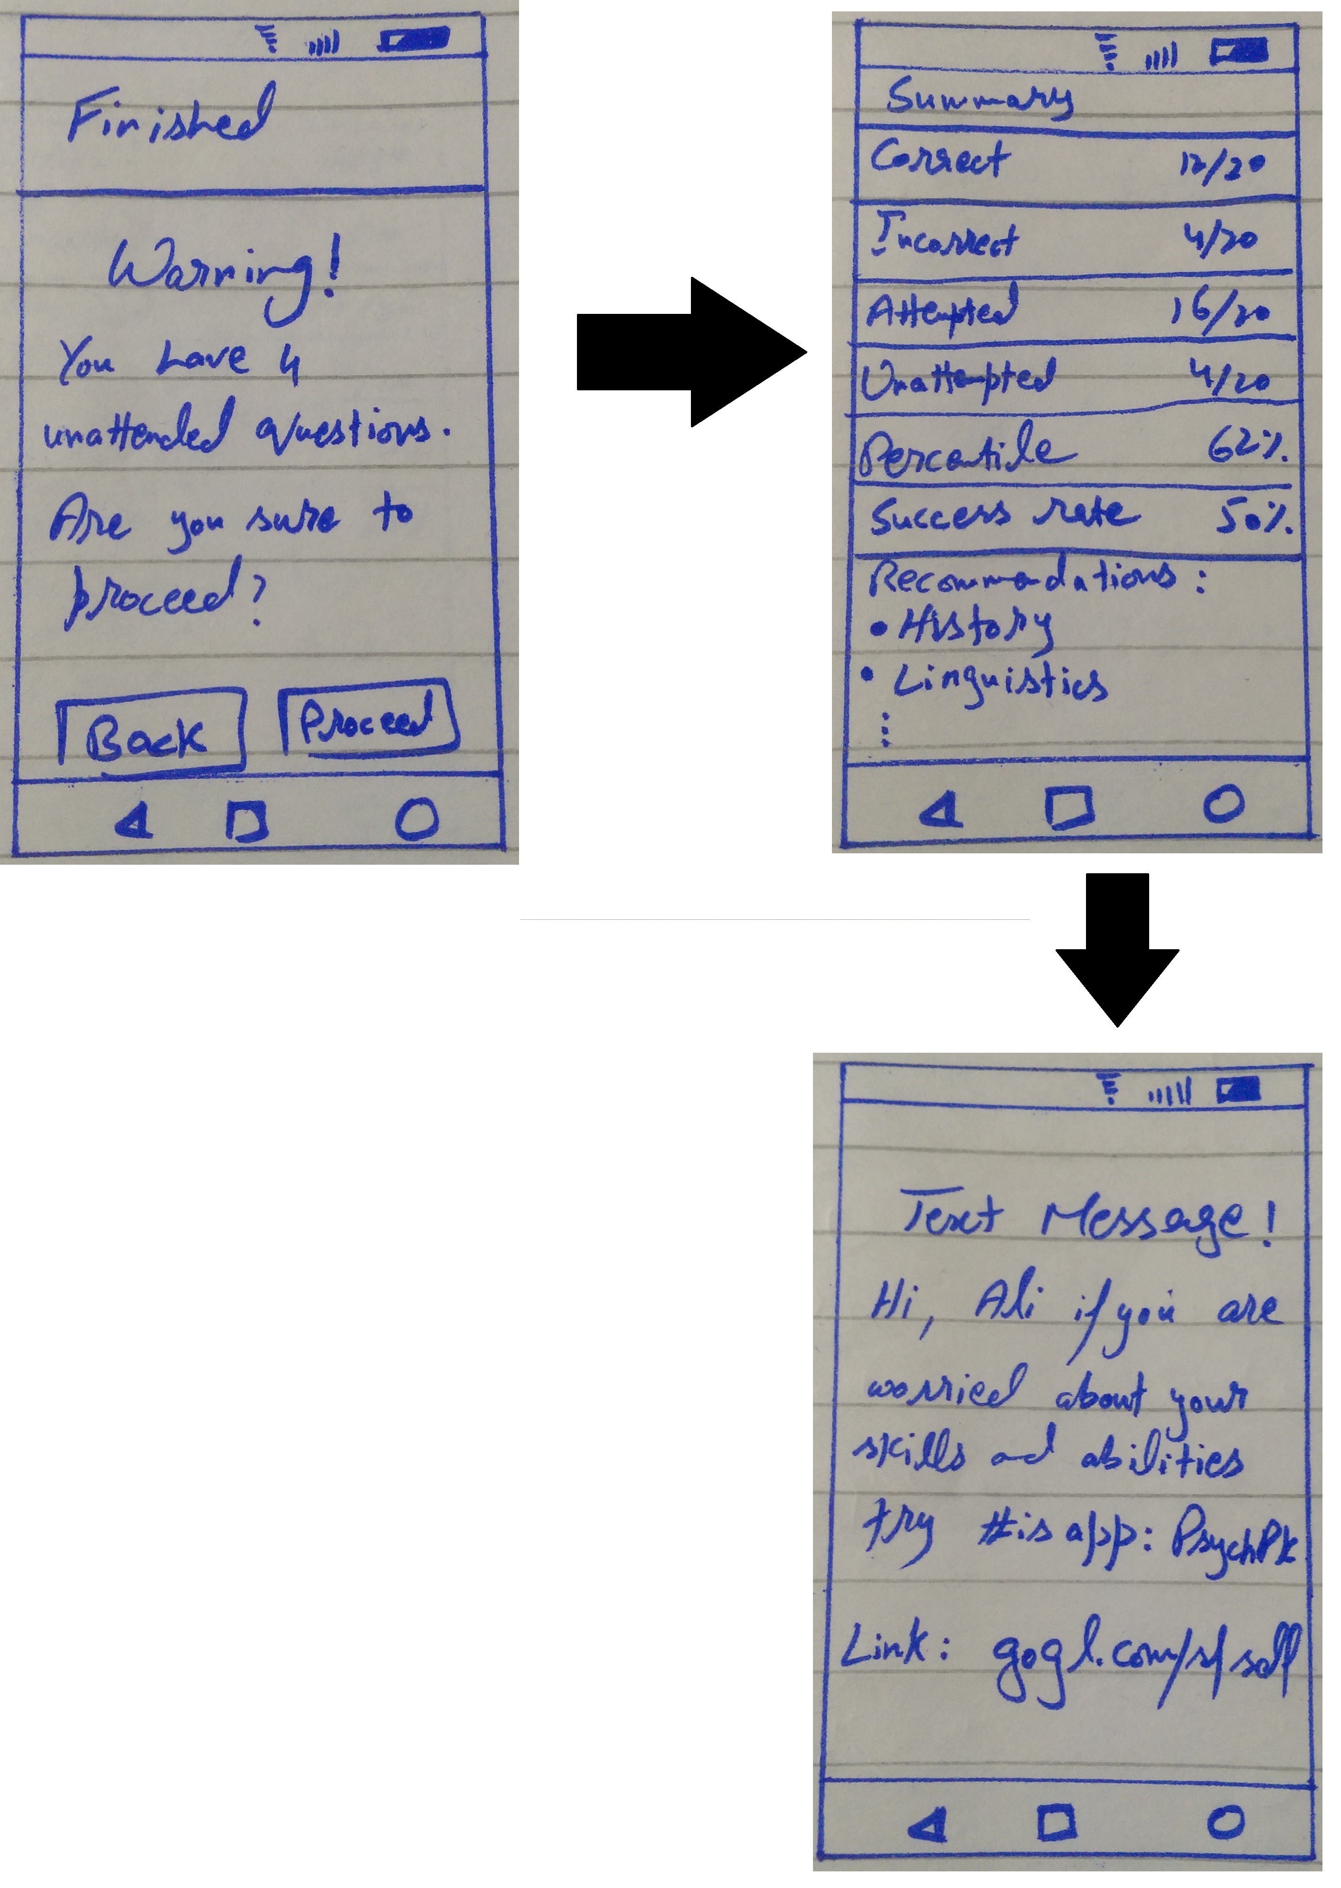

**Method:**

When you start the application, it will firstly show the title screen of app with logo “PyschPk”. Then it will show a pop up screen including modules for test taken by a user. A user will select a module for giving test, then this app will take user to the screen where selected module will show the details of number of questions included in that test and the given time. This screen will have the option to begin the test and the option to go back.

As user will select option to begin, the app will take user to the test screen, where total time passed for the test is mentioned at the top left bar of screen and the time passed for the current question at the top right bar of the screen. And then a progress bar and a bar showing the number of questions with back/next option. Then title of test is written in the middle of screen and the question to be answered with space of answer.

As you finished the test, the app will take you to screen where a warning message will be shown to user that will tell the status of test questions that how many questions have user missed. Then an option with back/proceed will be shown in the bottom of screen. As user proceed, the app will take user to the score/summary screen, where the summary of the test is written with all details and the recommendations for the user.

**Testing:**